URS Kaggle Titanic dataset data and ANN model development
Source: https://www.kaggle.com/datasets/mubeenshehzadi/decoding-survival-on-the-titanic
Variable overview:
- Survived: 0 = no; 1 = yes
- Passenger class (Pclass): 1 = first class; 2 = second class; 3 = third class
- Name: Passenger full name
- Sex: male or female
- Age: Passenger age in years
- SibSp: Number of siblings/spouses aboard
- Parch: Number of parents/children aboard
- Ticket: Ticket number
- Fare: Amount paid for the ticket in dollars
- Cabin: Cabin number (if assigned)
- Embarked: Port of embarkation (C = Cherbourg; Q = Queenstown; S = Southampton)
Objective: Predict survival probability of Titanic passengers using demographic and travel characteristics through comprehensive data analysis of 891 passengers and development of an ANN classification model.
Variable | Type | Description | Missing Values
PassengerId | Numerical | Unique passenger identifier (1-891) | 0
Survived | Categorical | Survival status (0 = No, 1 = Yes) | 0
Pclass | Categorical | Ticket class (1 = 1st, 2 = 2nd, 3 = 3rd) | 0
Name | Text | Passenger full name | 0
Sex | Categorical | Gender (male, female) | 0
Age | Numerical | Passenger age in years (0.4 - 80.0) | 177 (19.9%)
SibSp | Numerical | Number of siblings/spouses aboard (0-8) | 0
Parch | Numerical | Number of parents/children aboard (0-6) | 0
Ticket | Text | Ticket number | 0
Fare | Numerical | Ticket fare in dollars ($0.00 - $512.33) | 0
Cabin | Text | Cabin number | 687 (77.1%)
Embarked | Categorical | Port of embarkation (C, Q, S) | 2
Table 1 Dataset overview
Dataset Statistics:
- Total Passengers: 891
- Survival Rate: 38.38% (Survived: 342, Died: 549)
- Average Fare: $32.20
- Fare Range: $0.00 - $512.33
- Average Age: 29.70 years
- Age Range: 0.4 - 80.0 years
Passenger Class Distribution:
- 1st Class: 216 passengers (24.2%)
- 2nd Class: 184 passengers (20.7%)
- 3rd Class: 491 passengers (55.1%)
Gender Distribution:
- Male: 577 passengers (64.8%)
- Female: 314 passengers (35.2%)
Data Quality Assessment:
- Missing Age Values: 177 (19.9%) - Requires imputation with median
- Missing Cabin Values: 687 (77.1%) - High cardinality and sparsity; maybe drop
- Missing Embarked Values: 2 (0.2%) - Minimal; can be filled with mode (Southampton)

- Exploratory dataset analysis
The green box shows a median age of approximately 28 years with the interquartile range spanning ages 5-35. This younger median directly reflects the “women and children first” evacuation protocol: children and young adults (predominantly female) received priority evacuation.
The red box displays a median age around 32 years, approximately 4 years higher. Notably, the non-survivor group includes outlier elderly passengers (shown as individual points above 70 years), indicating that older passengers faced dramatically lower survival chances.
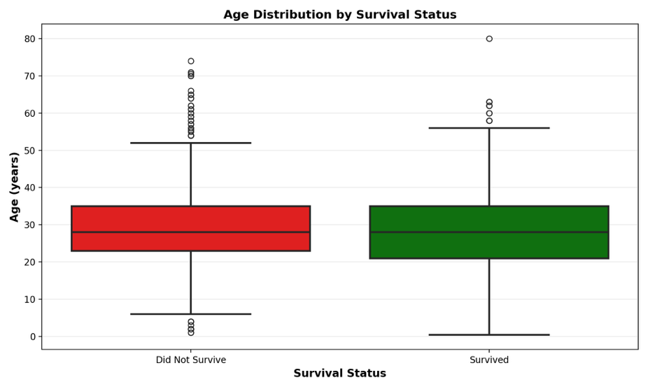

Below stacked bar plot shows a 55.3 percentage-point gap, meaning females had approximately 3.9 times better odds of survival than males. This extreme disparity reflects the strict enforcement of the “women and children first” evacuation protocol. The visual asymmetry confirms gender is unquestionably the most powerful single predictor of survival in the Titanic disaster.
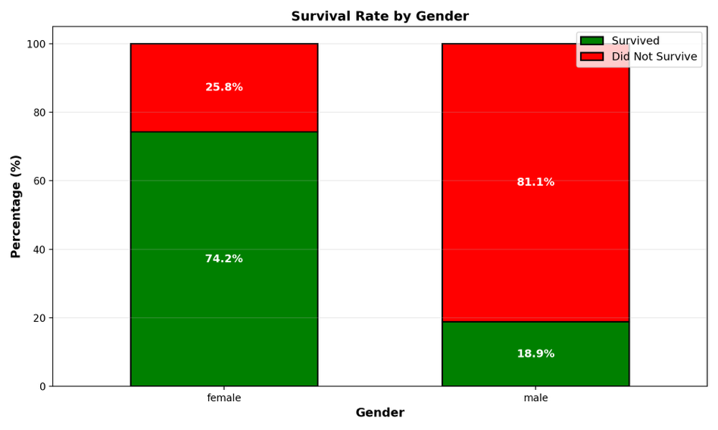
This creates a clear socioeconomic hierarchy in evacuation outcomes. First-class passengers had 2.6 times better survival odds compared to third-class. The stratification reflects tangible advantages:
- first-class held cabins located higher on the ship (closer to lifeboats), earlier notification of the emergency, and preferential access to lifeboat resources.
- Second-class occupies a clear intermediate position
confirming that passenger class is a rigid predictor of survival outcomes.
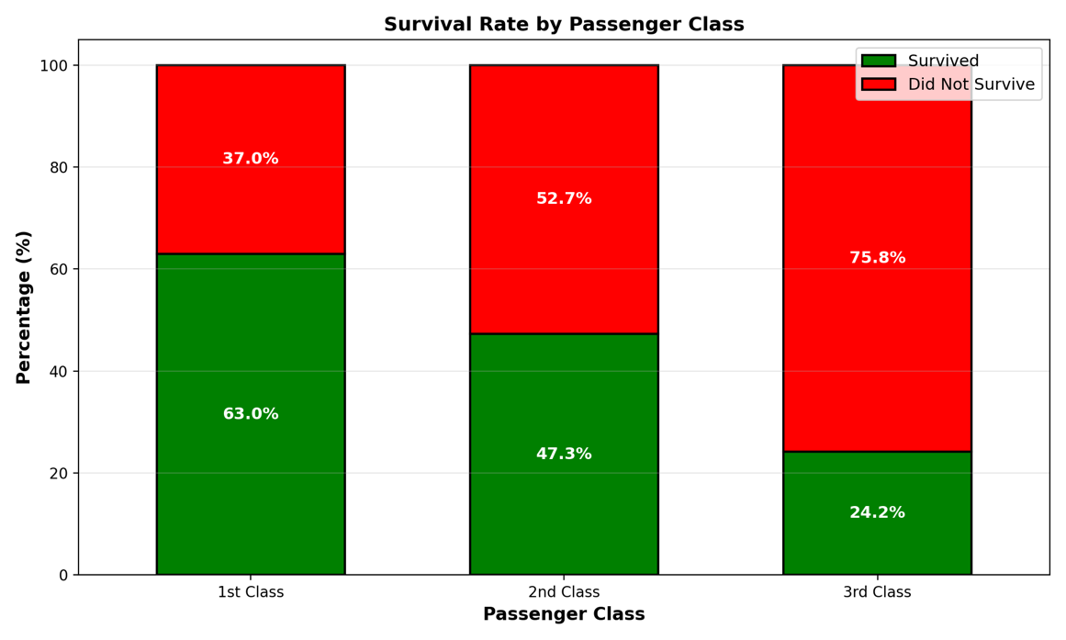

The green violin (Survived) displays a bimodal distribution with peaks at both high fares ($100+) and low fares ($0-20), reflecting that 1st-class passengers (high fare) had excellent survival rates, while some low-fare passengers (primarily women and children in 3rd class) also survived due to evacuation priority.

The red violin (Did Not Survive) shows a heavily concentrated distribution centered on low fares ($0-30), with few high-fare passengers represented. This distribution shape difference is stark, the “survived” group has much wider spread including high-fare concentrations, while the "did not survive" group is tightly clustered at low fares. This indicates fare is a moderate-strong predictor, serving as both a direct indicator of class and economic status.
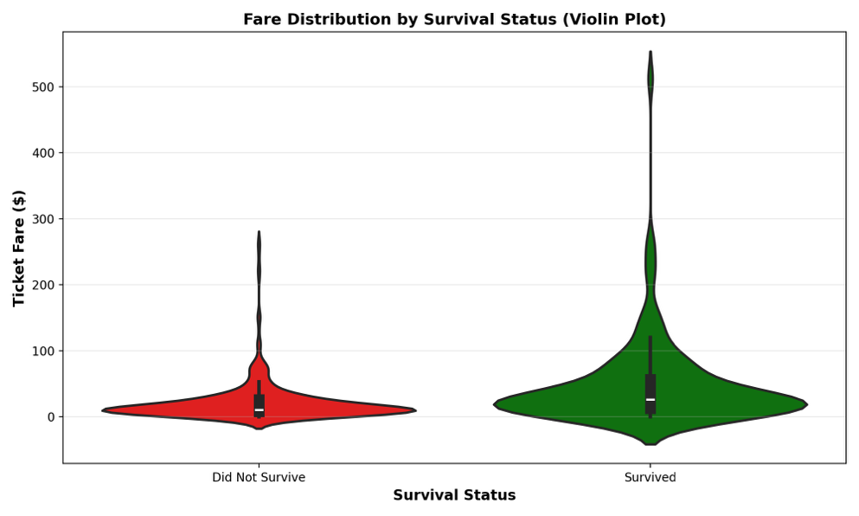
Children (0-5): 68.4% survival—the highest rate, reflecting maximum evacuation priority.
Children (6-12): 59.4% survival—still very high due to youth priority.
Teenagers (13-18): 33.3% survival—drops significantly as gender effects begin (older males overrepresent this group).
Young adults (19-35): 37.5% survival—moderate, primarily driven by females (74% of females survived vs. 19% of males).
Middle-aged (36-60): 23.8% survival—low, with mostly male passengers in this age range.
Elderly (60+): 21.1% survival—lowest rate, showing age discrimination in reverse (elderly had poor survival).
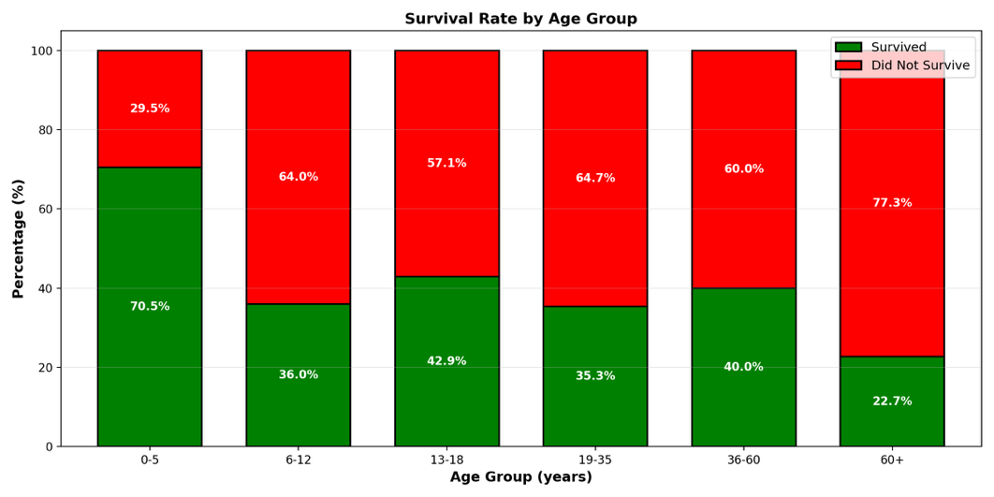
Solo travelers: 30.3% survival: the lowest, consisting primarily of male passengers with minimal evacuation priority.
Pairs (2 people): 38.8% survival: slightly higher, including couples (mixed gender outcomes) and siblings.
Small families (3-4): 44.8% survival: notably higher, as these groups included women and children who received priority evacuation.
Large families (5+): 16.7% survival: dramatically low, suggesting that large family groups faced logistical challenges (difficulty maintaining family cohesion during evacuation, insufficient lifeboat space for entire groups, or evacuation protocols prioritizing pairs over families).
-> family composition interacts with age/gender effects
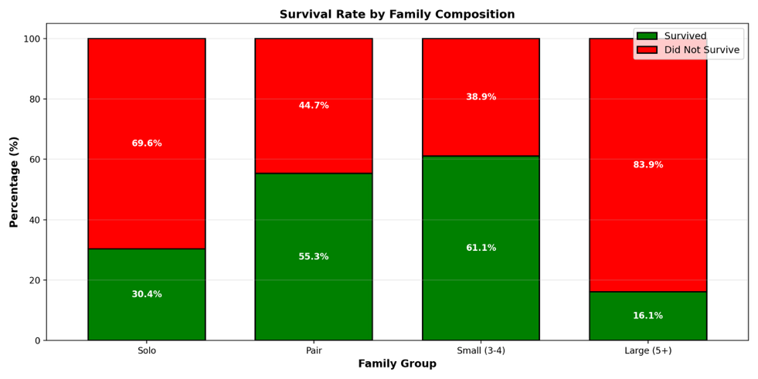

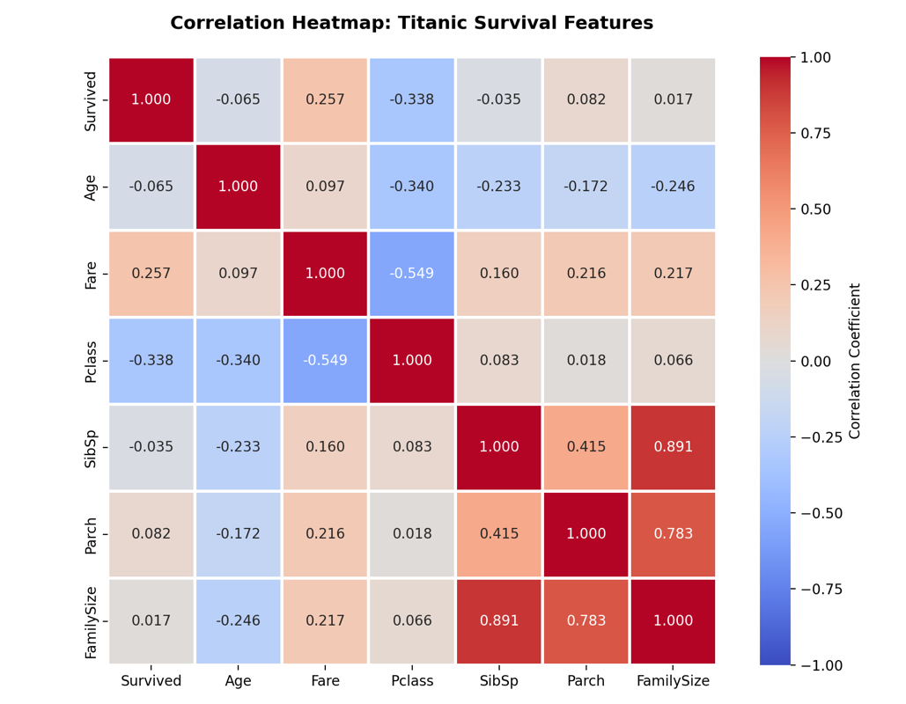
Strong correlations with survived (relatively)
Passenger class | -0.338 | 1st class correlates with higher survival probability
Fare | +0.257 | Higher fares correlate with survival  (This variable also correlates with passenger class. Has internal interaction)
Age | -0.070 | Younger passengers slightly more likely to survive
Weak correlation with survived
SibSp | -0.035 | Negligible
Family size | -0.016 | Negligible
Parch | +0.082 | Weak

The heatmap confirms that Pclass and Fare are the strongest numerical predictors, while family-related features are negligible.

Predictive feature ranking for future ANN model building
Gender | Strongest | 74% female vs 19% male
Passenger class | Very strong | 63% 1st vs 24% 3rd class
Fare | Moderate strong | r = 0.257
Age | Moderate | children 60%, elderly 21%
Family size | Weak | solo 30%, small 45%, large 17%
Sibsp/ Parch | Very weak | negligible correlations
- Build of ANN model
  - Data cleaning and preprocessing
Since this dataset introduces missing data value, before get into model building, we first need to clean and preprocess the data:
- Missing Age values (177 out of 891 = 19.9%): Filled with the median age (28.0 years) to preserve age distribution while eliminating NaN records
- Missing Fare values (1 record): Filled with median fare ($14.45)
- Missing Embarked values (2 records): Filled with mode (Southampton = 'S')
- Feature removal: PassengerId, Name, Ticket, and Cabin dropped (low predictive value or high sparsity)
- Feature engineering: Created FamilySize = SibSp + Parch + 1 (represents total family members aboard)
- Categorical encoding: One-hot encoded Sex and Embarked to create binary features
- Feature scaling: StandardScaler applied (mean=0, std=1) for stable gradient descent training
After the clearning and preprocessing of data, 891 samples are processed into 712 training, 179 test samples with 11 features after encoding.
  - Model architecture
- Input Layer: 11 neurons (representing encoded features: Pclass, Age, SibSp, Parch, Fare, FamilySize, Sex_female, Sex_male, Embarked_C, Embarked_Q, Embarked_S)
- Hidden Layer 1: 32 neurons with ReLU activation
- Hidden Layer 2: 16 neurons with ReLU activation
- Output Layer: 2 binary classification: Survived vs. Did Not Survive

  - ANN model evaluation
The training loss (blue) decreases smoothly from ~0.73 -> 0.36, showing the model fits training data progressively better. Validation loss (orange) follows closely, converging to ~0.46, indicating the model generalizes well (close to training loss means no severe memorization). Both curves flatten after epoch 50, meaning further training yields diminishing returns.
Training MAE (blue) decreases from ~0.35 -> 0.13, while validation MAE (orange) converges to ~0.18. This means the model's average prediction error shrinks steadily and stabilizes, confirming convergence.
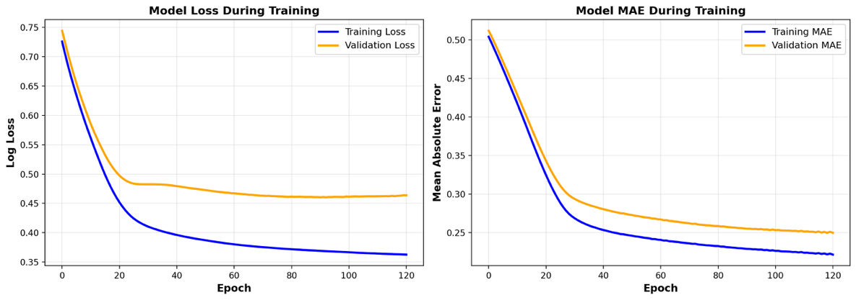
Strong learning

Visualizes the gap between validation and training loss to diagnose whether the model memorizes training data (overfitting) or is too simple (underfitting).
- Positive gap = overfitting,
- zero gap = perfect generalization,
- negative gap = underfitting.
The purple line shows validation loss minus training loss. The curve starts negative gradually increases, and stabilizes around +0.10. The red shaded “overfitting region” indicates where validation exceeds training loss.
The ~0.10 gap indicates mild overfitting, but the gap shows slow growing, meaning the model hasn't runaway memorized.
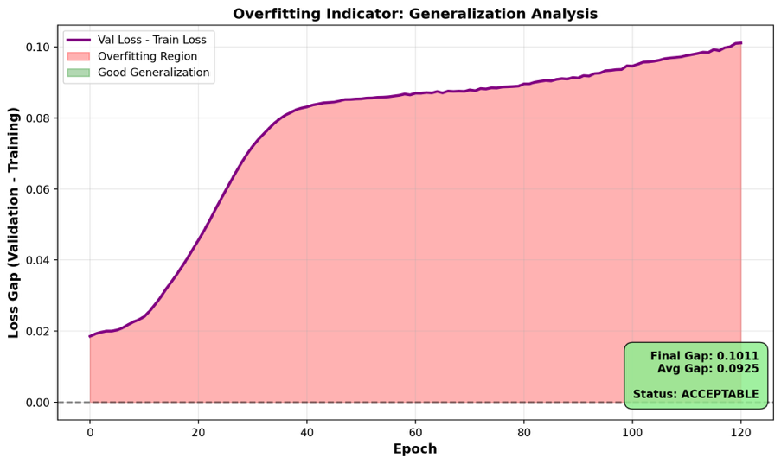
Overfitting phase
Plateaus
Model learns broad, generalizable pattern

Using accuracy lone sometimes is misleading, especially for a binary classification. Accuracy measures the percentage of correct predictions overall: (true positive + true negative) / total
** TP: The model correctly predicted a positive outcome
** TN: The model correctly predicted a negative outcome
It seems intuitive that focusing on correctly predicted outcome; however, it also hides critical information about what type of error the model makes. Therefore, we introduce the use of ROC curve:
The ROC (Receiver Operating Characteristic) Curve is a graph that evaluates classification performance across all possible decision thresholds, not just one fixed point. It plots two metrics:
- X-axis (False Positive Rate): Of all people who did NOT survive, how many did the model incorrectly predict as survivors?
  - Formula: FP / (FP + TN) = False Positives / Total Negatives
  - Range: 0% (no false alarms) to 100% (all flagged as survivors)
- Y-axis (True Positive Rate / Recall): Of all people who DID survive, how many did the model correctly identify?
  - Formula: TP / (TP + FN) = True Positives / Total Positives
  - Range: 0% (misses all survivors) to 100% (catches all survivors)
Blue Curve (ANN Model):
- AUC = 0.8526 (Area Under Curve)
- The curve hugs the top-left corner, indicating excellent discrimination ability
- At a 20% false positive rate (accepting 20 false survivors), the model achieves a 75% true positive rate (catches 75% of actual survivors)
- This represents an excellent trade-off: catching most survivors while maintaining reasonable precision
Green Curve (Logistic Regression):
- AUC = 0.8433
- Nearly overlaps with the ANN curve, showing almost identical performance
- At 20% false positive rate, achieves approximately 72% true positive rate
- Slightly lower performance than ANN, but the difference (0.93%) is negligible in practice

